3 лаба элтекс, Нуриева, сети

Тема: Настройка агрегирования каналов

Все команды для настройки включаются в отчет в текстовом виде, не скриншоты.

nb! - отметка в тексте, "обратите особое внимание"

Для заданной на схеме schema-lab3 сети, состоящей из управляемых коммутаторов и персональных компьютеров

настроить на коммутаторах протокол LACP агрегирования каналов технологии EtherChannel

show running config//

Чтобы узнать соседей, пронеймим свичи, и введем команду

Switch> enable

Switch# configure terminal

Switch(config)# hostname SW1 //нэймим

Switch>show cdp neighbors //смотрим какие соседи через какие интерфейсы подключены

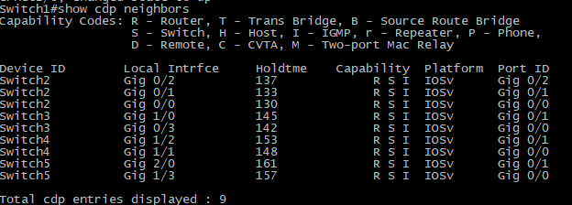

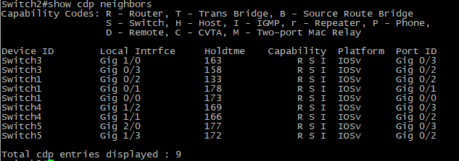

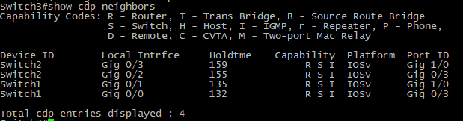

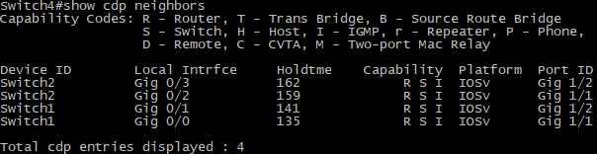

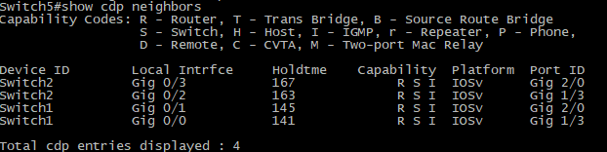

Channel-group

|  |  |  |
| --- | --- | --- |
| Интерфейс | #ком | Channel-group |
| Gig0/0 | 2 | 1 |
| Gig0/1 | 2 | 1 |
| Gig0/2 | 2 | 1 |
| Gig0/3 | 3 | 2 |
| Gig1/0 | 3 | 2 |
| Gig1/1 | 4 | 4 |
| Gig1/2 | 4 | 4 |
| Gig1/3 | 5 | 6 |
| Gig2/0 | 5 | 6 |

Channel--groupSW2

|  |  |  |
| --- | --- | --- |
| 0/0 | 1 | 1 |
| 0/1 | 1 | 1 |
| 0/2 | 1 | 1 |
| 0/3 | 3 | 3 |
| 1/0 | 3 | 3 |
| 1/1 | 4 | 5 |
| 1/2 | 4 | 5 |
| 1/3 | 5 | 7 |
| 2/0 | 5 | 7 |

Channel--groupSW3

|  |  |  |
| --- | --- | --- |
| 0/0 | 1 | 2 |
| 0/1 | 1 | 2 |
| 0/2 | 2 | 3 |
| 0/3 | 2 | 3 |

Channel--groupSW4

|  |  |  |
| --- | --- | --- |
| 0/0 | 1 | 4 |
| 0/1 | 1 | 4 |
| 0/2 | 2 | 5 |
| 0/3 | 2 | 5 |

Channel--groupSW5

|  |  |  |
| --- | --- | --- |
| 0/0 | 1 | 6 |
| 0/1 | 1 | 6 |
| 0/2 | 2 | 7 |
| 0/3 | 2 | 7 |

Настройка свичей

enable

configure terminal

interface range GigabitEthernetn/n,GigabitEthernetn/n

channel-group n mode active

exit

2. Получить статистику пакетов для портов коммутаторов (nb!: show interfaces stats), результаты сохранить в файл, создать некоторый трафик между различными персональными компьютерами при помощи утилиты ping, сохранить новую статистику (рекомендуется использовать таблицы excel или его opensource аналоги для наглядности)

ip ПК

|  |  |
| --- | --- |
| 1 | 192.168.1.1 |
| 2 | 192.168.1.2 |
| 3 | 192.168.1.3 |
| 4 | 192.168.1.4 |
| 5 | 192.168.1.5 |
| 6 | 192.168.1.6 |

Cтатистика пакетов для портов коммутаторов

|  |
| --- |
| Switch1 |
| GigabitEthernet0/0  Switching path Pkts In Chars In Pkts Out Chars Out  Processor 931 74126 2138 155959  Route cache 0 0 0 0  Total 931 74126 2138 155959  GigabitEthernet0/1  Switching path Pkts In Chars In Pkts Out Chars Out  Processor 742 62860 621 63717  Route cache 0 0 0 0  Total 742 62860 621 63717  GigabitEthernet0/2  Switching path Pkts In Chars In Pkts Out Chars Out  Processor 739 62261 648 66147  Route cache 0 0 0 0  Total 739 62261 648 66147  GigabitEthernet0/3  Switching path Pkts In Chars In Pkts Out Chars Out  Processor 5916 352178 5099 336020  Route cache 0 0 0 0  Total 5916 352178 5099 336020  GigabitEthernet1/0  Switching path Pkts In Chars In Pkts Out Chars Out  Processor 1167 86282 1322 108426  Route cache 0 0 0 0  Total 1167 86282 1322 108426  GigabitEthernet1/1  Switching path Pkts In Chars In Pkts Out Chars Out  Processor 3225 203476 3652 246450  Route cache 0 0 0 0  Total 3225 203476 3652 246450  GigabitEthernet1/2  Switching path Pkts In Chars In Pkts Out Chars Out  Processor 1214 87171 1690 128007  Route cache 0 0 0 0  Total 1214 87171 1690 128007  GigabitEthernet1/3  Switching path Pkts In Chars In Pkts Out Chars Out  Processor 5890 357931 2188 157156  Route cache 0 0 0 0  Total 5890 357931 2188 157156  GigabitEthernet2/0  Switching path Pkts In Chars In Pkts Out Chars Out  Processor 2368 152944 1220 98850  Route cache 0 0 0 0  Total 2368 152944 1220 98850  Port-channel6  Switching path Pkts In Chars In Pkts Out Chars Out  Processor 1979 126998 0 0  Route cache 0 0 0 0  Total 1979 126998 0 0  Port-channel4  Switching path Pkts In Chars In Pkts Out Chars Out  Processor 1087 75672 0 0  Route cache 0 0 0 0  Total 1087 75672 0 0  Port-channel2  Switching path Pkts In Chars In Pkts Out Chars Out  Processor 2553 162090 0 0  Route cache 0 0 0 0  Total 2553 162090 0 0  Port-channel1  Switching path Pkts In Chars In Pkts Out Chars Out  Processor 577 82794 0 0  Route cache 0 0 0 0  Total 577 82794 0 0 |
| Switch2 |
| GigabitEthernet0/0  Switching path Pkts In Chars In Pkts Out Chars Out  Processor 24044 1413086 17818 1179856  Route cache 0 0 0 0  Total 24044 1413086 17818 1179856  GigabitEthernet0/1  Switching path Pkts In Chars In Pkts Out Chars Out  Processor 33954 2197771 159174 12068749  Route cache 0 0 0 0  Total 33954 2197771 159174 12068749  GigabitEthernet0/2  Switching path Pkts In Chars In Pkts Out Chars Out  Processor 39693 2625351 126154 9531007  Route cache 0 0 0 0  Total 39693 2625351 126154 9531007  GigabitEthernet0/3  Switching path Pkts In Chars In Pkts Out Chars Out  Processor 21061 1218262 185737 13864046  Route cache 0 0 0 0  Total 21061 1218262 185737 13864046  GigabitEthernet1/0  Switching path Pkts In Chars In Pkts Out Chars Out  Processor 20157 1168839 184144 13768035  Route cache 0 0 0 0  Total 20157 1168839 184144 13768035  GigabitEthernet1/1  Switching path Pkts In Chars In Pkts Out Chars Out  Processor 21293 1229645 185849 13870857  Route cache 0 0 0 0  Total 21293 1229645 185849 13870857  GigabitEthernet1/2  Switching path Pkts In Chars In Pkts Out Chars Out  Processor 20195 1163613 184322 13776290  Route cache 0 0 0 0  Total 20195 1163613 184322 13776290  GigabitEthernet1/3  Switching path Pkts In Chars In Pkts Out Chars Out  Processor 193736 14156128 33192 2301632  Route cache 0 0 0 0  Total 193736 14156128 33192 2301632  GigabitEthernet2/0  Switching path Pkts In Chars In Pkts Out Chars Out  Processor 125811 9016392 19181 1247374  Route cache 0 0 0 0  Total 125811 9016392 19181 1247374  Port-channel7  Switching path Pkts In Chars In Pkts Out Chars Out  Processor 2470 147391 0 0  Route cache 0 0 0 0  Total 2470 147391 0 0  Port-channel5  Switching path Pkts In Chars In Pkts Out Chars Out  Processor 561 42584 0 0  Route cache 0 0 0 0  Total 561 42584 0 0  Port-channel3  Switching path Pkts In Chars In Pkts Out Chars Out  Processor 661 58169 0 0  Route cache 0 0 0 0  Total 661 58169 0 0  Port-channel1  Switching path Pkts In Chars In Pkts Out Chars Out  Processor 2084 166661 0 0  Route cache 0 0 0 0  Total 2084 166661 0 0 |
| Switch3 |
| GigabitEthernet0/0  Switching path Pkts In Chars In Pkts Out Chars Out  Processor 143867 10385801 20649 1350115  Route cache 0 0 0 0  Total 143867 10385801 20649 1350115  GigabitEthernet0/1  Switching path Pkts In Chars In Pkts Out Chars Out  Processor 167913 12370733 18399 1212719  Route cache 0 0 0 0  Total 167913 12370733 18399 1212719  GigabitEthernet0/2  Switching path Pkts In Chars In Pkts Out Chars Out  Processor 150855 10921906 20438 1326890  Route cache 0 0 0 0  Total 150855 10921906 20438 1326890  GigabitEthernet0/3  Switching path Pkts In Chars In Pkts Out Chars Out  Processor 146323 10628526 19977 1300364  Route cache 0 0 0 0  Total 146323 10628526 19977 1300364  GigabitEthernet1/0  Switching path Pkts In Chars In Pkts Out Chars Out  Processor 0 0 118981 9023561  Route cache 0 0 0 0  Total 0 0 118981 9023561  GigabitEthernet1/1  Switching path Pkts In Chars In Pkts Out Chars Out  Processor 0 0 118979 9023059  Route cache 0 0 0 0  Total 0 0 118979 9023059  Port-channel3  Switching path Pkts In Chars In Pkts Out Chars Out  Processor 1822 118051 0 0  Route cache 0 0 0 0  Total 1822 118051 0 0  Port-channel2  Switching path Pkts In Chars In Pkts Out Chars Out  Processor 4231 249288 0 0  Route cache 0 0 0 0  Total 4231 249288 0 0 |
| Switch4 |
| GigabitEthernet0/0  Switching path Pkts In Chars In Pkts Out Chars Out  Processor 243205 18082825 19555 1282085  Route cache 0 0 0 0  Total 243205 18082825 19555 1282085  GigabitEthernet0/1  Switching path Pkts In Chars In Pkts Out Chars Out  Processor 142728 10420914 18557 1221032  Route cache 0 0 0 0  Total 142728 10420914 18557 1221032  GigabitEthernet0/2  Switching path Pkts In Chars In Pkts Out Chars Out  Processor 156013 11316611 20705 1343103  Route cache 0 0 0 0  Total 156013 11316611 20705 1343103  GigabitEthernet0/3  Switching path Pkts In Chars In Pkts Out Chars Out  Processor 155729 11346286 20173 1307630  Route cache 0 0 0 0  Total 155729 11346286 20173 1307630  GigabitEthernet1/0  Switching path Pkts In Chars In Pkts Out Chars Out  Processor 0 0 171283 13052113  Route cache 0 0 0 0  Total 0 0 171283 13052113  GigabitEthernet1/1  Switching path Pkts In Chars In Pkts Out Chars Out  Processor 0 0 171273 13051343  Route cache 0 0 0 0  Total 0 0 171273 13051343  Port-channel5  Switching path Pkts In Chars In Pkts Out Chars Out  Processor 1623 97603 0 0  Route cache 0 0 0 0  Total 1623 97603 0 0  Port-channel4  Switching path Pkts In Chars In Pkts Out Chars Out  Processor 2187 134261 0 0  Route cache 0 0 0 0  Total 2187 134261 0 0 |
| Switch5 |
| GigabitEthernet0/0  Switching path Pkts In Chars In Pkts Out Chars Out  Processor 218162 16445348 43465 2932664  Route cache 0 0 0 0  Total 218162 16445348 43465 2932664  GigabitEthernet0/1  Switching path Pkts In Chars In Pkts Out Chars Out  Processor 17709 1050645 198878 14934028  Route cache 0 0 0 0  Total 17709 1050645 198878 14934028  GigabitEthernet0/2  Switching path Pkts In Chars In Pkts Out Chars Out  Processor 35453 2288217 191886 14292734  Route cache 0 0 0 0  Total 35453 2288217 191886 14292734  GigabitEthernet0/3  Switching path Pkts In Chars In Pkts Out Chars Out  Processor 19421 1127829 201371 15073930  Route cache 0 0 0 0  Total 19421 1127829 201371 15073930  GigabitEthernet1/0  Switching path Pkts In Chars In Pkts Out Chars Out  Processor 0 0 179143 13750518  Route cache 0 0 0 0  Total 0 0 179143 13750518  GigabitEthernet1/1  Switching path Pkts In Chars In Pkts Out Chars Out  Processor 0 0 179116 13748787  Route cache 0 0 0 0  Total 0 0 179116 13748787  Port-channel7  Switching path Pkts In Chars In Pkts Out Chars Out  Processor 1873 118073 0 0  Route cache 0 0 0 0  Total 1873 118073 0 0  Port-channel6  Switching path Pkts In Chars In Pkts Out Chars Out  Processor 1171 89780 0 0  Route cache 0 0 0 0  Total 1171 89780 0 0 |

Примеры ping с разных ПК

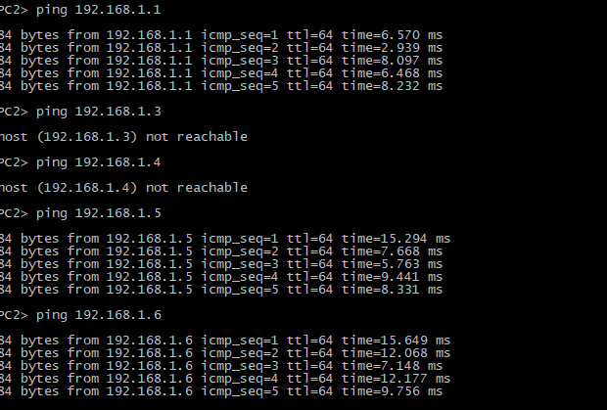

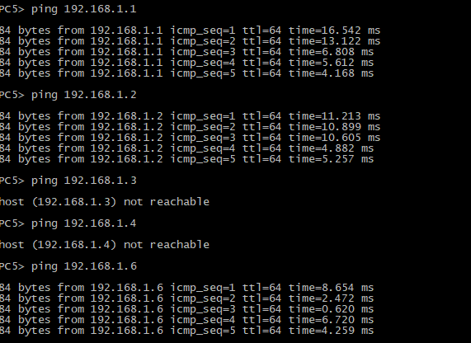

Cтатистика пакетов для портов коммутаторов после команды ping

|  |
| --- |
| Switch1 |
| GigabitEthernet0/0  Switching path Pkts In Chars In Pkts Out Chars Out  Processor 1289 105693 3129 230147  Route cache 0 0 0 0  Total 1289 105693 3129 230147  GigabitEthernet0/1  Switching path Pkts In Chars In Pkts Out Chars Out  Processor 1096 93409 898 92127  Route cache 0 0 0 0  Total 1096 93409 898 92127  GigabitEthernet0/2  Switching path Pkts In Chars In Pkts Out Chars Out  Processor 1096 93764 964 98067  Route cache 0 0 0 0  Total 1096 93764 964 98067  GigabitEthernet0/3  Switching path Pkts In Chars In Pkts Out Chars Out  Processor 9706 578243 8154 536338  Route cache 0 0 0 0  Total 9706 578243 8154 536338  GigabitEthernet1/0  Switching path Pkts In Chars In Pkts Out Chars Out  Processor 1635 127377 1732 149200  Route cache 0 0 0 0  Total 1635 127377 1732 149200  GigabitEthernet1/1  Switching path Pkts In Chars In Pkts Out Chars Out  Processor 3673 242783 4564 315599  Route cache 0 0 0 0  Total 3673 242783 4564 315599  GigabitEthernet1/2  Switching path Pkts In Chars In Pkts Out Chars Out  Processor 1423 107518 2019 158045  Route cache 0 0 0 0  Total 1423 107518 2019 158045  GigabitEthernet1/3  Switching path Pkts In Chars In Pkts Out Chars Out  Processor 7632 480386 2489 187742  Route cache 0 0 0 0  Total 7632 480386 2489 187742  GigabitEthernet2/0  Switching path Pkts In Chars In Pkts Out Chars Out  Processor 3001 207659 1525 128992  Route cache 0 0 0 0  Total 3001 207659 1525 128992  Port-channel6  Switching path Pkts In Chars In Pkts Out Chars Out  Processor 2734 187780 0 0  Route cache 0 0 0 0  Total 2734 187780 0 0  Port-channel4  Switching path Pkts In Chars In Pkts Out Chars Out  Processor 1187 91675 0 0  Route cache 0 0 0 0  Total 1187 91675 0 0  Port-channel2  Switching path Pkts In Chars In Pkts Out Chars Out  Processor 4379 276470 0 0  Route cache 0 0 0 0  Total 4379 276470 0 0  Port-channel1  Switching path Pkts In Chars In Pkts Out Chars Out  Processor 866 129121 0 0  Route cache 0 0 0 0  Total 866 129121 0 0 |
| Switch2 |
| GigabitEthernet0/0  Switching path Pkts In Chars In Pkts Out Chars Out  Processor 25809 1537058 18009 1200433  Route cache 0 0 0 0  Total 25809 1537058 18009 1200433  GigabitEthernet0/1  Switching path Pkts In Chars In Pkts Out Chars Out  Processor 34411 2238268 159361 12088633  Route cache 0 0 0 0  Total 34411 2238268 159361 12088633  GigabitEthernet0/2  Switching path Pkts In Chars In Pkts Out Chars Out  Processor 40221 2671913 126342 9551015  Route cache 0 0 0 0  Total 40221 2671913 126342 9551015  GigabitEthernet0/3  Switching path Pkts In Chars In Pkts Out Chars Out  Processor 21470 1254147 187014 13953829  Route cache 0 0 0 0  Total 21470 1254147 187014 13953829  GigabitEthernet1/0  Switching path Pkts In Chars In Pkts Out Chars Out  Processor 20570 1205032 184476 13799274  Route cache 0 0 0 0  Total 20570 1205032 184476 13799274  GigabitEthernet1/1  Switching path Pkts In Chars In Pkts Out Chars Out  Processor 21705 1266065 187124 13960101  Route cache 0 0 0 0  Total 21705 1266065 187124 13960101  GigabitEthernet1/2  Switching path Pkts In Chars In Pkts Out Chars Out  Processor 20358 1180352 184624 13803691  Route cache 0 0 0 0  Total 20358 1180352 184624 13803691  GigabitEthernet1/3  Switching path Pkts In Chars In Pkts Out Chars Out  Processor 199164 14483787 34966 2421246  Route cache 0 0 0 0  Total 199164 14483787 34966 2421246  GigabitEthernet2/0  Switching path Pkts In Chars In Pkts Out Chars Out  Processor 126364 9062805 19447 1275638  Route cache 0 0 0 0  Total 126364 9062805 19447 1275638  Port-channel7  Switching path Pkts In Chars In Pkts Out Chars Out  Processor 5080 302224 0 0  Route cache 0 0 0 0  Total 5080 302224 0 0  Port-channel5  Switching path Pkts In Chars In Pkts Out Chars Out  Processor 654 57626 0 0  Route cache 0 0 0 0  Total 654 57626 0 0  Port-channel3  Switching path Pkts In Chars In Pkts Out Chars Out  Processor 845 87423 0 0  Route cache 0 0 0 0  Total 845 87423 0 0  Port-channel1  Switching path Pkts In Chars In Pkts Out Chars Out  Processor 2938 240781 0 0  Route cache 0 0 0 0  Total 2938 240781 0 0 |
| Switch3 |
| GigabitEthernet0/0  Switching path Pkts In Chars In Pkts Out Chars Out  Processor 149110 10708283 22473 1471049  Route cache 0 0 0 0  Total 149110 10708283 22473 1471049  GigabitEthernet0/1  Switching path Pkts In Chars In Pkts Out Chars Out  Processor 168508 12422934 18673 1240602  Route cache 0 0 0 0  Total 168508 12422934 18673 1240602  GigabitEthernet0/2  Switching path Pkts In Chars In Pkts Out Chars Out  Processor 153327 11086968 20672 1351546  Route cache 0 0 0 0  Total 153327 11086968 20672 1351546  GigabitEthernet0/3  Switching path Pkts In Chars In Pkts Out Chars Out  Processor 146928 10679065 20211 1324635  Route cache 0 0 0 0  Total 146928 10679065 20211 1324635  GigabitEthernet1/0  Switching path Pkts In Chars In Pkts Out Chars Out  Processor 44 3666 120323 9119082  Route cache 0 0 0 0  Total 44 3666 120323 9119082  GigabitEthernet1/1  Switching path Pkts In Chars In Pkts Out Chars Out  Processor 46 3964 120330 9119687  Route cache 0 0 0 0  Total 46 3964 120330 9119687  Port-channel3  Switching path Pkts In Chars In Pkts Out Chars Out  Processor 3024 201003 0 0  Route cache 0 0 0 0  Total 3024 201003 0 0  Port-channel2  Switching path Pkts In Chars In Pkts Out Chars Out  Processor 6609 390038 0 0  Route cache 0 0 0 0  Total 6609 390038 0 0 |
| Switch4 |
| GigabitEthernet0/0  Switching path Pkts In Chars In Pkts Out Chars Out  Processor 244855 18199226 19795 1307131  Route cache 0 0 0 0  Total 244855 18199226 19795 1307131  GigabitEthernet0/1  Switching path Pkts In Chars In Pkts Out Chars Out  Processor 142972 10442938 18756 1240416  Route cache 0 0 0 0  Total 142972 10442938 18756 1240416  GigabitEthernet0/2  Switching path Pkts In Chars In Pkts Out Chars Out  Processor 158572 11487548 20945 1368149  Route cache 0 0 0 0  Total 158572 11487548 20945 1368149  GigabitEthernet0/3  Switching path Pkts In Chars In Pkts Out Chars Out  Processor 155972 11368607 20341 1325030  Route cache 0 0 0 0  Total 155972 11368607 20341 1325030  GigabitEthernet1/0  Switching path Pkts In Chars In Pkts Out Chars Out  Processor 26 2004 172172 13118455  Route cache 0 0 0 0  Total 26 2004 172172 13118455  GigabitEthernet1/1  Switching path Pkts In Chars In Pkts Out Chars Out  Processor 26 2004 172162 13117685  Route cache 0 0 0 0  Total 26 2004 172162 13117685  Port-channel5  Switching path Pkts In Chars In Pkts Out Chars Out  Processor 2691 162876 0 0  Route cache 0 0 0 0  Total 2691 162876 0 0  Port-channel4  Switching path Pkts In Chars In Pkts Out Chars Out  Processor 2799 175850 0 0  Route cache 0 0 0 0 |
| Switch5 |
| GigabitEthernet0/0  Switching path Pkts In Chars In Pkts Out Chars Out  Processor 218610 16484874 44210 2988839  Route cache 0 0 0 0  Total 218610 16484874 44210 2988839  GigabitEthernet0/1  Switching path Pkts In Chars In Pkts Out Chars Out  Processor 18172 1090410 199172 14963123  Route cache 0 0 0 0  Total 18172 1090410 199172 14963123  GigabitEthernet0/2  Switching path Pkts In Chars In Pkts Out Chars Out  Processor 38510 2474852 194424 14456673  Route cache 0 0 0 0  Total 38510 2474852 194424 14456673  GigabitEthernet0/3  Switching path Pkts In Chars In Pkts Out Chars Out  Processor 19812 1163664 201678 15103577  Route cache 0 0 0 0  Total 19812 1163664 201678 15103577  GigabitEthernet1/0  Switching path Pkts In Chars In Pkts Out Chars Out  Processor 41 3474 180050 13819084  Route cache 0 0 0 0  Total 41 3474 180050 13819084  GigabitEthernet1/1  Switching path Pkts In Chars In Pkts Out Chars Out  Processor 47 4028 180025 13817617  Route cache 0 0 0 0  Total 47 4028 180025 13817617  Port-channel7  Switching path Pkts In Chars In Pkts Out Chars Out  Processor 3303 209002 0 0  Route cache 0 0 0 0  Total 3303 209002 0 0  Port-channel6  Switching path Pkts In Chars In Pkts Out Chars Out  Processor 1327 114833 0 0  Route cache 0 0 0 0  Total 1327 114833 0 0 |